You are required to use database BookDB to be able to answer the below questions

Make a search publishers frame:

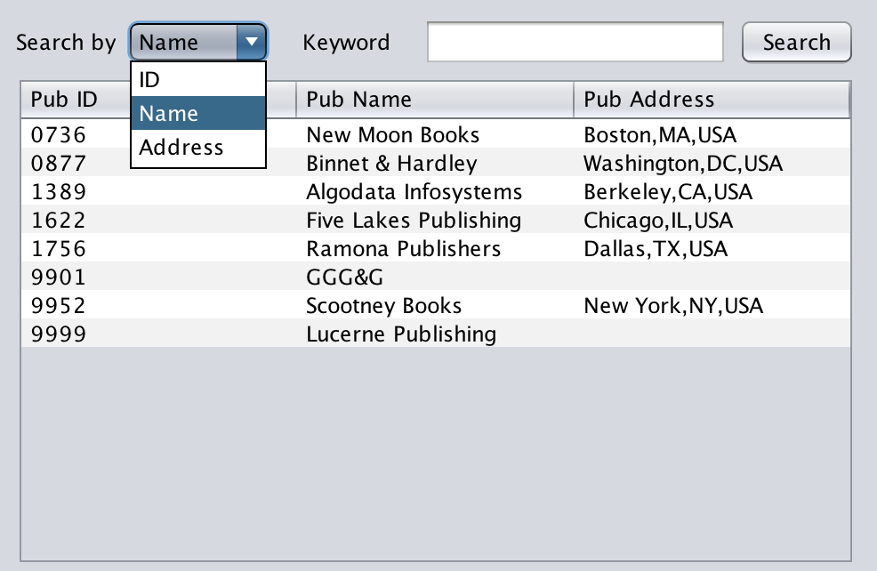

When users select search criterial and enter keyword, do the searching and output information of books which matched search criterial to table. Clear the table and output an error message if the searching does not find any matched record.

